

**Rajokri Institute of Technology, DSEU**

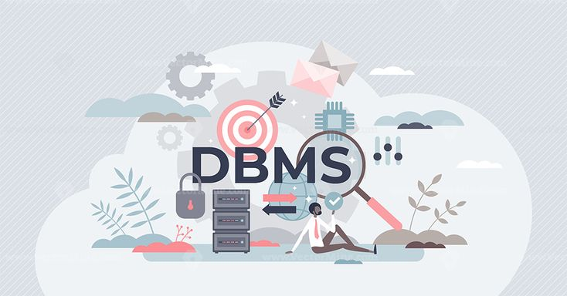



**B.Sc. DATA ANALYTICS 2023 -25**

Name: PAWAN PARIDA

Semester: 2nd

Subject: DATABASE MANAGEMENT SYSTEMS

Subject Faculty: Dr. Sunita Chaurasia

**PRACTICAL INDEX**

|  |  |  |  |
| --- | --- | --- | --- |
| **S.NO** | **PRACTICALS** | **REMARKS** | **SIGNATURE** |
| **1** | **To understand database and its architecture** |  |  |
| **2** | **To understand SQL and its various subsystems** |  |  |
| **3** | **To understand various datatypes used in DBMS**  **along with examples** |  |  |
| **4** | **To understand Create command in SQL** |  |  |
| **5** | **To understand Alter command in SQL** |  |  |
| **6** | To understand Truncate and Drop commands in SQL. |  |  |
| **7** | To understand SELECT statement in SQL. |  |  |
| **8** | To understand UPDATE command in SQL. |  |  |
| **9** | To understand DELETE command in SQL. |  |  |
| **10** | **Aim-To understand aggregate commands like sum, count, avg, max and min .** |  |  |
| **11** | **Aim-To understand Group by clause in SQL.** |  |  |
| **12** | Aim-To understand Order by clause in SQL |  |  |

### DATABASE

A database is a structured collection of data that is organized and managed to facilitate efficient storage, retrieval, and manipulation. It serves as a central repository for storing information, allowing users and applications to interact with the data in a controlled and consistent manner.

### DATABASE ARCHITECTURE

Database architecture refers to the structural design and methodology of a **Database Management System (DBMS)**. It plays a crucial role in how data is stored, organized, and retrieved. Let’s explore the different aspects of database architecture:

#### 1-Tier Architecture:

* + 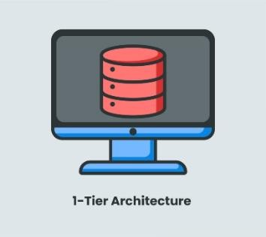In this architecture, the database is directly available to the user. Users can directly interact with the DBMS, and any changes made affect the database itself.
  + It is commonly used for local applications during

development, where programmers need quick access to the database.

* + However, it lacks a convenient tool for end users.

#### 13 Basic SAP Terms Explained (+ the SAP Full Forms) – INUI2-Tier Architecture:

* + Similar to basic client-server architecture.
  + Applications on the client side communicate directly with the database server.
  + APIs like ODBC and JDBC facilitate this interaction.
  + User interfaces and application programs run on the

client side, while the server side handles query processing and transaction management.

#### 3-Tier Architecture:

* + 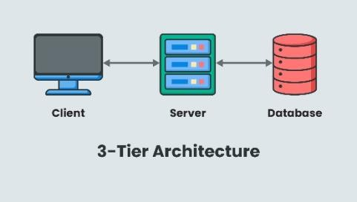Contains an additional layer between the client and server.
  + The client interacts with an application server, which then communicates with the database system.
  + End users are unaware of the database beyond the application server.
  + Commonly used for large web applications.

### SQL

SQL (Structured Query Language) is a powerful tool used for managing and interacting with relational databases. Let’s delve into its key aspects:

#### Definition and Purpose:

* + SQL allows us to organize, manage, and retrieve data from a computer database.
  + Originally known as **Structured English Query Language (SEQUEL)**, it was later abbreviated to SQL.
  + When we need to retrieve data from a database, we use SQL to make requests.
  + The **Database Management System (DBMS)** processes SQL queries, retrieves the requested data, and returns it to us.
  + SQL statements describe how data should be organized or what data should be extracted or added to the database.

#### SQL Subsystems:

* + **Data Definition Language (DDL)**: Used to define the structure and organization of stored data (e.g., creating tables, defining constraints).
  + **Data Manipulation Language (DML)**: Handles data retrieval, addition, modification, and deletion (e.g., SELECT, INSERT, UPDATE, DELETE).
  + **Data Control Language (DCL)**: Manages access control and permissions (e.g., GRANT, REVOKE).
  + **Data Query Language (DQL):** DQL is used for querying data from the database.
  + **Transaction Control Language (TCL)**: Ensures data consistency and integrity (e.g., COMMIT, ROLLBACK).

## Aim-To understand various datatypes used in DBMS along with examples.

#### Data Types

* Data type of a column defines what value the column can store in the table
* Defined while creating tables in database
* Data types mainly classified into three categories and most used
  + String: char, varchar, etc
  + Numeric: int, float, bool, etc
  + Date and time: date, datetime, etc

1. Numeric Data Types:
   * INT: Represents whole numbers (e.g., employee IDs, order numbers). Example: id INTEGER PRIMARY KEY.
   * TINYINT: Stores small integers (range: -128 to 127).
   * BIGINT: Handles large integers (range: -9,223,372,036,854,775,808 to 9,223,372,036,854,775,807).
   * FLOAT and REAL: Store floating-point numbers (e.g., prices, measurements).
2. String Data Types:
   * CHAR(x): Fixed-length character strings (max 8000 characters). Example: name CHAR(50).
   * VARCHAR(x): Variable-length character strings (max 8000 characters). Example: address VARCHAR(255).
   * TEXT: Stores large text data (up to 2 GB). Example: description TEXT.
3. Date and Time Data Types:
   * DATETIME: Represents date and time (from January 1, 1753 to December 31, 9999).
   * DATE: Stores only dates (from January 1, 0001 to December 31, 9999).
   * TIME: Stores only time.
4. Binary Data Types:
   * BINARY(x): Fixed-length binary strings.
   * VARBINARY(x): Variable-length binary strings.
   * IMAGE: Stores binary data (up to 2 GB). Commonly used data types

* int: used for the integer value
* float: used to specify a decimal point number
* bool: used to specify Boolean values true and false
* char: fixed length string that can contain numbers, letters, and special characters
* date: date format YYYY-MM-DD
* datetime: date and time combination, format is YYYY-MM-DD hh:mm:ss

DDL is a crucial part of SQL that deals with defining and modifying the structure of database objects. Here’s a breakdown of DDL commands:

### CREATE:

The CREATE command is fundamental in DDL. It is used to create entire databases and their objects, such as tables.

When creating a table, follow this syntax:

CREATE TABLE <table_name> (

<column_1> <sql_datatype>,

<column_2> <sql_datatype>,

...

<column_N> <sql_datatype>

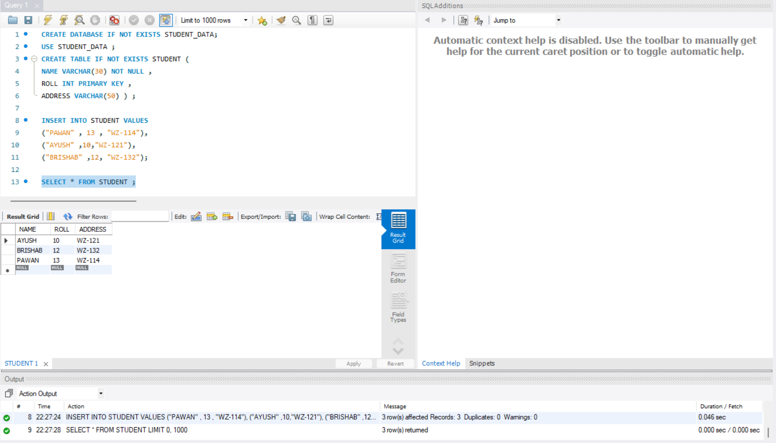);

## Aim-To understand Alter command in SQL.

### ALTER:

The ALTER command is used to modify the structure of the database. The ALTER TABLE statement in SQL is used to modify an existing table.

**Adding a Column**: To add a new column to an

Existing table, use the following syntax:

ALTER TABLE table_name

ADD column_name datatype;

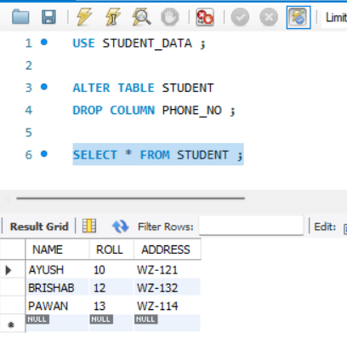

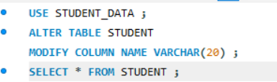

**Rename**: changing table name

ALTER TABLE table_name RENAME to new_name;

**Changing Data Type**: To modify the data type of a column, use the appropriate syntax based on your database system:

ALTER TABLE table_name

MODIFY COLUMN column_name datatype;

**Dropping a Column**: To delete a column from a table,

use the following syntax (note that some databases

may not allow column deletion):

ALTER TABLE table_name DROP COLUMN column_name;

**PRACTICLE 6**

## Aim-To understand Truncate and Drop commands in SQL.

### TRUNCATE:

The TRUNCATE command removes all records from a table, including the space allocated for those records.

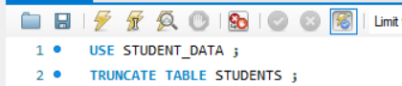

### DROP:

The DROP command is used to delete objects from the database.

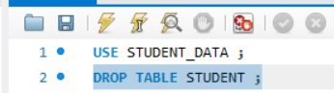

**PRACTICLE 7**

## Aim-To understand SELECT statement in SQL.

The SQL SELECT statement is used to retrieve data from a database table. It is the most common and fundamental query in SQL.

Syntax for whole table-

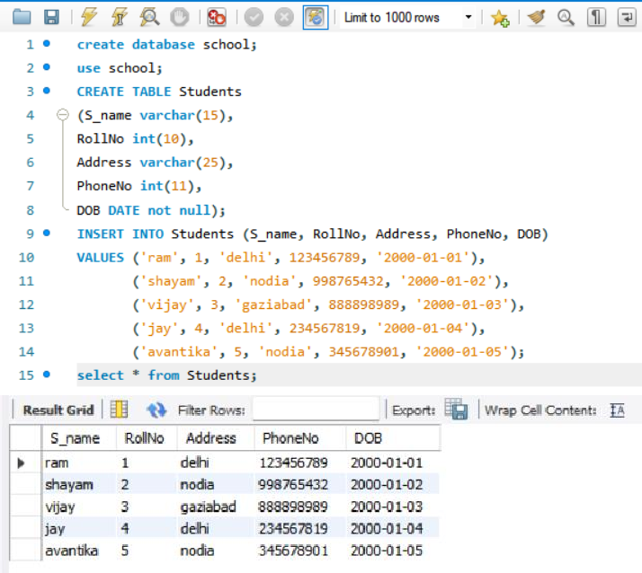SELECT * FROM CUSTOMERS;

SELECT column1, column2 , columnN FROM table_name;

**PRACTICLE 8**

## Aim-To understand UPDATE command in SQL.

The SQL UPDATE command is used to update existing rows in a table by changing the values of one or more columns.

Syntax-

UPDATE table_name

SET column1 = value1, column2 = value2, ... WHERE condition;

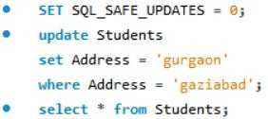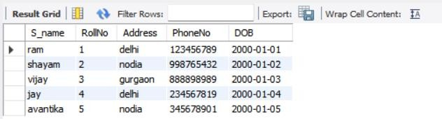

# PRACTICLE 9

## Aim-To understand DELETE command in SQL.

To delete records in SQL, you can use the DELETE statement followed by the table name and the WHERE clause to specify the conditions for the records to be deleted.

Syntax-

* Delete records from a table based on a condition:

DELETE FROM table_name WHERE condition;

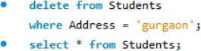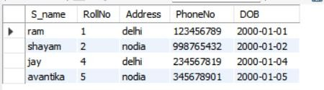

* Delete all records from a table:

DELETE FROM table_name;

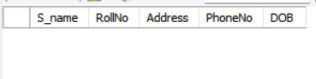

# PRACTICLE 10

**Aim-To understand aggregate commands like sum, count, avg, max and min .**

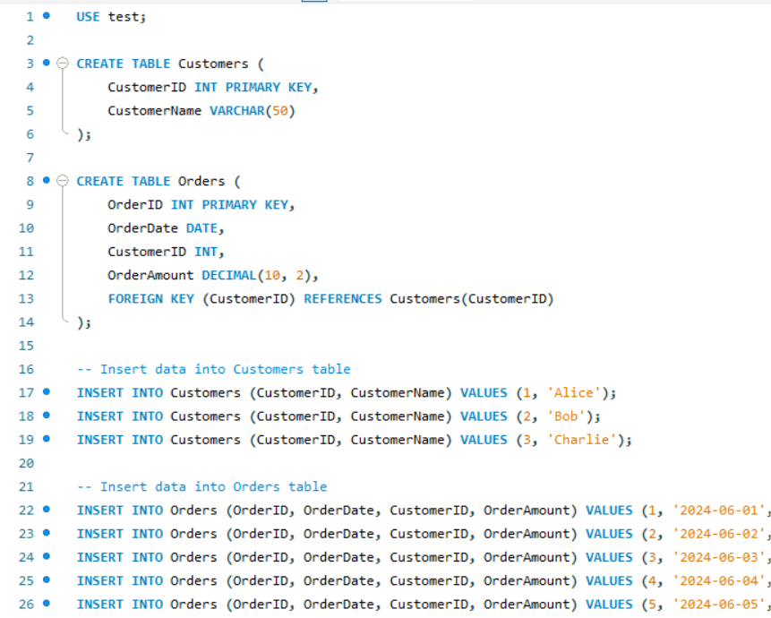

# PRACTICLE 11

**Aim-To understand Group by clause in SQL.**

*****

# PRACTICLE 12

# Aim-To understand Order by clause in SQL

# 

